Abstract

Introduction
According to the World Bank, organic waste accounts for approximately 44-46% by mass of total municipal waste production (Kaza et al., 2018). Managing this fraction remains a key challenge for local decision-makers, especially with regulations evolving toward circular economy. The most widely used technologies for treating biowaste are are anaerobic digestion and composting (Gilbert and Siebert, 2022). These processes may have different configurations, depending on their scale (for example home versus industrial composting), as well as on the type of by-products generated (particularly in the case of anaerobic digestion, biogas can be converted into electricity, heat, or upgraded to biomethane (Kapoor et al., 2020)). Nevertheless, the choice of an appropriate system should consider multiple factors specific to a territory, in order to ensure its viability (Anne et al., 2025).
A key parameter in planning a biowaste management system is the available feedstock, which depends on both the quantity of waste generated and the fraction effectively sorted by citizens. In Europe, although source separation of biowaste has been mandatory since January 2024, significant disparities remain across countries. For example, the capture rate of food waste exceeds 70% in Italy, while it remains below 5% in Greece (Favoino and Giavini, 2024). Even within the same country, there is variability from one territory to another. In France, in areas where separate collection systems are implemented, the amount of food waste collected ranged from 20 to 60 kg per capita in 2019 (Gentric et al., 2022). This variability in feedstock availability highlights the challenges associated with selecting and sizing appropriate treatment systems.
Another key issue for municipalities is the level of centralization of the waste management system to be implemented. Unlike decentralized solutions such as home composting, centralized systems involve the transport of waste, which generates both environmental and economic costs (Schoefs et al., 2024; Weidner et al., 2020). In rural areas, the collection distance is more pronounced due to dispersed settlements (ts-admin, 2024). However, centralized systems have the advantage of generating higher value co-products (Schoefs et al., 2024). Nevertheless, as highlighted by Anne et al. (2025), the deployment of such technologies ultimately depends on the existence of local outlets for these co-products.
LCA of organic waste management
From an environmental perspective, several Life Cycle Assessment (LCA) studies have been conducted to compare different organic management systems and to attempt to identify the most suitable one. These comparisons typically involve an existing scenario and one or more alternatives ((Angelo et al., 2017; Behrooznia et al., 2020; Liu et al., 2022; Oliveira et al., 2017; Zeller et al., 2020)), or explore multiple hypothetical scenarios ((Al-Rumaihi et al., 2020; Angouria-Tsorochidou et al., 2022; Ardolino et al., 2018; Ashraf et al., 2025; Bahramian et al., 2025; Weidner et al., 2020)). In most cases, a scenario is defined by a single treatment technology, while environmental performance of hybrid systems is rarely assessed. In practice, conventional comparative LCA approaches remain limited in their ability to allows to test a limited strategy, which restricts the identification of near-optimal system configurations across a wide range of possibilities.
Several optimization frameworks have been developed to overcome the limitations of conventional LCA and support the planning of waste management systems. Most of these approaches focus on municipal solid waste, treating biowaste as a specific stream for which the optimizer must identify an appropriate treatment pathway (Münster et al., 2015; Roberts et al., 2018; Sardarmehni et al., 2022; Tascione et al., 2016). The set of technologies typically considered includes both conventional waste treatment options, such as landfilling and incineration, as well as biological processes tailored to organic waste, including composting and anaerobic digestion. Among these studies, Lin et al. (2022) stand out by focusing exclusively on biowaste flows and by incorporating an additional technology—high-temperature drying sterilization—for the production of livestock feed. However, many of these frameworks are applied at large spatial scales, often considering entire countries as the system boundary, despite the fact that municipal waste management is primarily a local responsibility (UNEP, 2024). For instance, Münster et al., (2015) optimized the management of municipal waste in Denmark with the objective of minimizing climate change impacts, while Lin et al., (2022) conducted a national-scale optimization for Malaysia, targeting ecosystem quality, human health, and economic costs. Such large-scale approaches limit the applicability of results for local decision-making, as they may fail to capture territory-specific characteristics that influence both the feasibility and environmental performance of the system, such as collection and transport distance. The existence of markets for co-products - another key territorial parameter - is neglected in these optimization frameworks. While substitution is often associated with significant environmental benefits in LCA, its realization depends on the availability of a market for the substituted product (Weidema, 2003). Without sufficient demand, substitution cannot occur, and the associated environmental benefits may be overestimated.
To address these limitations, this study proposes an optimization framework designed to capture fine-scale territorial specificities along the entire value chain, with the objective of minimizing environmental impacts. The capabilities of the framework are demonstrated through a case study. In addition, the influence of different local strategies—such as the choice of impact indicator and the inclusion of investment decisions—is systematically assessed.

Method

Optimization framework

Terminology definition
Table 1 presents all the parameters used in the optimization model.
Table 1 : Parameters used in the optimization model
Symbol | Definition | Units
m | Municipality
MUN | Set of municipalities within the territory
o | Source of biowaste
O | Set of possible waste sources, including single-family households and multi-family housing.
sf | Single-family households
mf | Multi-family housing
M(m,o) | Mass of biowaste generated in municipality m from origin o | ton
t | A treatment technology
T | Set of treatment technologies
lb(t) | Minimum capacity of t
ub(t) | Maximum capacity of t
s | Treatment facility location
S | Set of potential facility locations
poss_tech(t,s) | Binary parameter equal to 1 if site s can host technology t, and 0 otherwise
Cp | Co-product of biowaste treatment
CP | Set of co-products
convp | Conventional product that can be substituted by a coproduct
ConvP | Set of conventional products
Mark | Market where a co-product can be valorized
MARK | Set of co-product markets
Poss_mark(cp, mark) | Binary parameter equal to 1 if mark can receive cp, and 0 otherwise
$$d_{c}\left(m\right)$$ | Waste collection distance within municipality m | km
$$d\left(m,s\right)$$ | Distance between municipality m and site s | km
$$d(s,mark)$$ | Distance between a site s and a market mark | km
CAP(convp) | Maximum market capacity for conventional products within the territory
$$y_{cp,t}$$ | Rate of production of cp by t | Unit of cp/ton of waste
$$γ_{cp,conv_{p}}$$ | Substitution rate of a conventional product by a coproduct

Definition of variables
The optimization framework is designed to track materials flows along the entire value chain, from waste producers to treatment technologies and downstream coproduct markets. Accordingly, three decision variables are defined:
- $x(m, o, t, s)$: flow of biowaste generated in municipality m from source o, sent to technology t located at site s
- $y(t, s)$: binary variable equal to 1 if technology t is activated (installed) at site s, and 0 otherwise
- $z(t,cp,s,mark)$: flow of co-coproduct cp produced by technology t at site s and delivered to market mark.

Objective function
The optimization aims to minimize the environmental impact of biowaste management system, as defined by the following objective function:
Min. $F_{i}=\sum_{m,t,o,s}{x\left(m,o,t,s\right).\left(I_{{col}_{i}}\left(m\right)+I_{{tr}_{i}}\left(m,s\right)+I_{i}\left(t\right)-I_{{sub}_{i}}\left(t\right)+I_{{use of cp}_{i}}\left(t\right)\right)}+\sum_{t,s, cp, mark}{z\left(t,s,cp,mark\right)}I_{{tr-cp}_{i}}$
Where:
- $i$ : the impact indicator to minimize
- $I_{{col}_{i}}\left(m\right)$ : the impact of the collection of 1 ton of waste in the municipality m, calculated based on the collection distance $d_{c}\left(m\right)$
- $I_{{tr}_{i}}\left(m,s\right)$ : the impact of the transport of 1 ton of waste from the municipality m to a site s, calculated based on the distance $d\left(m,s\right)$
- $I_{i}(t)$ : the impact of treatment of 1 ton of waste with the technology $t$
- $I_{{sub}_{i}}(t)$ : the total avoided impact associated to coproducts that $t$ generates:
$$I_{{sub}_{i}}\left(t\right)=\sum_{cp, convp}{y_{cp,t}.}γ_{cp,conv_{p}}.I_{{convp}_{i}}$$
  - $I_{{convp}_{i}} :$ the impact associated with the production of one unit of a conventional product
- $I_{{use of cp}_{i}}(t)$ : the net impact associated with the uses of all coproducts that $t$ generates
$$I_{{use of cp}_{i}}(t) = \sum_{cp, convp}{y_{cp,t}.}(I_{{use}_{i}}(cp) - γ_{cp,conv_{p}}.I_{{use}_{i}}(convp))$$
  - $I_{{use}_{i}}(cp)$ : the impact associated with the use phase of one unit of a coproduct cp
  - $I_{{use}_{i}}(convp)$: the impact associated with the use phase of one unit of a conventional product convp
- $I_{{tr-cp}_{i}}\left(cp, t, s, mark\right)$ : the impact of the transport of one unit of coproduct cp produced from t installed in a site s and send to a market mark, calculated based on the distance $d(s,mark)$

Normalization method for multi-objective optimization
In the case of multi-objective optimization, each impact indicator is normalized relative to the impact of current system. The objective function is therefore expressed as follows:
Min. $G = \sum_{i}{\frac{W_{i}}{N_{i}}.F_{i}}$
Where:
- $W_{i}$ : Weight of the impact indicator i
- $N_{i}$ : impact of current system for indicator i

Constraints
All the constraints in the optimization model are detailed in the Table 2.
Table 2 : Constraints in the optimization model
Constraints | Equations/Inequations
All source-separated biowaste must be treated | $∀m∈MUN :$  $$\sum_{s}{\sum_{t in tech}{x\left(m,sf,t,s\right)}}=M_{home,m}$$  $$\sum_{s}{\sum_{t in tech}{x(m,mf,t,s)}}=M_{build,m}$$
The amount of biowaste processed by each technology must respect its capacity limits | $$∀t∈T, ∀s∈S:$$  $$\sum_{o in origin}{\sum_{m in mun}{x\left(m,o,t,s\right)≤ub\left(t\right)*y(t,s)}}$$  $$\sum_{o in origin}{\sum_{m in mun}{x\left(m,o,t,s\right)≥lb\left(t\right)*y(t,s)}}$$
A technology can only be installed at a site where it is feasible | $$∀t∈T,∀s∈S,ifposs-tech\left(t,s\right)=0:$$  $$\sum_{m}{\sum_{o}{x\left(m,o,t,s\right)}}=0$$
All co-products generated must be allocated to markets | $∀t∈T,∀s∈S, ∀cp∈CP$:  $$\sum_{mark}{z(t,s,cp,mark)}=\sum_{m}{\sum_{o}{x\left(m,o,t,s\right)*}}y_{cp,t}$$
A co-product can only be sent to a compatible market | $∀cp∈CP,∀mark∈MARK, if poss(cp,mark)=0$:  $$\sum_{t}{\sum_{s}{z\left(t,s,cp,mark\right)=0}}$$
The avoided impact from cp is limited by the market size of the conventional product being substituted | $∀convp∈ConvP$:  $$\sum_{cp,t,s,mark}{z\left(t,cp,s,mark\right).}γ_{cp,conv_{p}}.I_{{convp}_{i}}≤CAP\left(convp\right).I_{{convp}_{i}}$$

LCA of biowaste treatment technologies

Goal and scope
This section aims to compare the different waste treatment technologies that are later integrated into the optimization framework. The functional unit is defined as the treatment of 1 tonne of biowaste. As the technologies generate co-products, multifunctionality is addressed using a system expansion approach. In line with the case study presented below, the geographical scope of the LCA is defined as France.

Description of technologies
The two main categories of technologies assessed in this study are composting and anaerobic digestion. Composting is further distinguished into home composting and industrial composting. Both processes produce compost, which provides fertilizing functions through its nitrogen (N), phosphorus (P), and potassium (K) content, as well as soil amendment functions due to its carbon content (e.g., [ref]). Consequently, the avoided processes include the production and use of mineral fertilizers and peat, which deliver similar functions to those of compost.
Anaerobic digestion technologies differ according to the post-treatment of both biogas and digestate. Regarding biogas, three valorization pathways are considered: (i) combined heat and power (CHP) generation, producing both electricity and heat; (ii) direct combustion to produce heat; and (iii) upgrading to biomethane. Heat is assumed to substitute heat produced from natural gas, while electricity replaces marginal electricity production. The use phase of heat and electricity derived from biogas is assumed to generate impacts equivalent to those of the substituted energy. In contrast, biomethane injected into the gas grid directly substitutes natural gas. In this case, the use phase is explicitly included in the system boundaries, as the combustion of natural gas releases fossil carbon, unlike biomethane.
Regarding digestate, it can be directly applied to land after storage, providing fertilizing functions (N, P, K). Unlike compost, it is assumed not to provide a soil amendment function, as digestate is typically applied in agricultural contexts where such functions are less critical (e.g., [ref]). Alternatively, digestate can be further composted to produce compost with similar properties and functions to that derived from biowaste composting.
Based on the different combinations of biogas and digestate treatment pathways, six types of anaerobic digestion systems are distinguished. In this study, technology labels reflect the co-products generated. For example, AD-elec-heat-dig refers to anaerobic digestion with CHP production and direct land application of digestate.
System boundaries exclude the transport of biowaste, as this aspect is territory-specific and addressed separately in the optimization framework.
The technologies under study are presented in Figures […].
The system boundaries exclude the transport of biowaste, as distances are dependent on the specific territory considered.
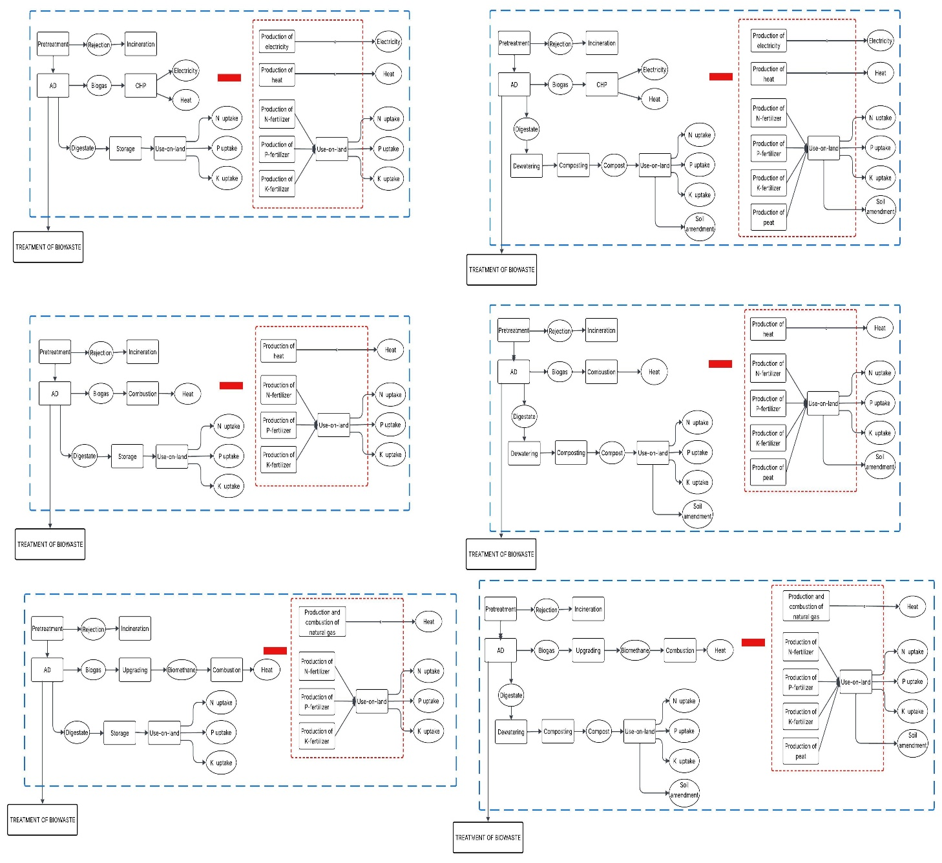

Life cycle inventory
Inventory data for home and industrial composting were obtained using the PaCTEA tool developed by (Ravoahangy et al., 2026). Data for anaerobic digestion technologies were compiled from multiple literature sources. A detailed description of all inventory data is provided in the Appendix.
Resources and emissions related to the background processes are obtained from ecoinvent database (version 3.9).

Life cycle impact assessment
For impact assessment, we used Impact World+ v2.1 method. Specifically, the footprint version was used to calculate climate change impacts, while the expert version was applied for the damage categories ecosystem quality and human health.

Case study

Territory description
The optimization framework was applied to a territory located in northern France, namely the Agglomération de la Région de Compiègne (ARC). This intermunicipal authority comprises 22 municipalities, including both rural and urban areas.
The total amount of household biowaste generated in 2023 was estimated at 5,347 tonnes. This quantity is used as the basis for the optimization. Currently, no dedicated treatment system for biowaste is implemented in the territory. As biowaste is still mixed with residual household waste, it is primarily treated through incineration.
The input data required for the optimization at the municipal level are detailed in the Supporting information.

Existing technologies
At the departemental scale, several industrial facilities dedicated to organic waste treatment have been identified (Figure 1). We assume that these facilities can process the biowaste generated by the territory. The information used to characterize these installations were obtained from publicly available sources and supplemented with assumptions where necessary.

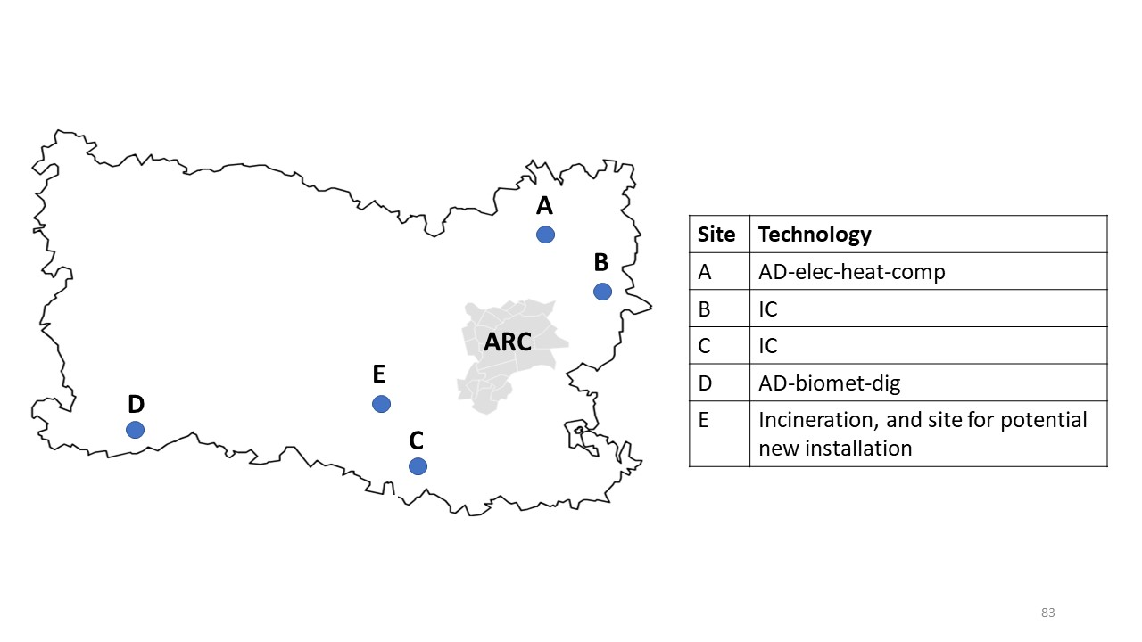
Figure 1 : Geographical location of the ARC territory and the existing biowaste treatment facilities
In the scenario allowing new investments a new biowaste treatment facility is assumed to be located in Villers-Saint-Paul, where a municipal solid waste incineration plant is currently operating.
The distances between each facility and each municipality of ARC, as well as capacity constraints of each installation, are detailed in Supporting information.

Co-product markets within the territory

Fertilizer market
According to UNIFA, France consumed 1,831 kt of nitrogen (N), 316 kt of phosphorus (P), and 354 kt of potassium (K) in 2024. These are the most recent data available, and no significant variation is assumed for future years.
To estimate the fertilizer market at the ARC scale, a uniform per capita consumption across France is assumed. Based on this approach, the annual fertilizer demand within the ARC is estimated at 2.25 kt for N, 0.39 kt for P, and 0.44 kt for K.

Peat market
Peat accounts for approximately 45% of the volume of growing media in France (source). The growing media market is divided into two segments: a professional market (1,670,000 m³/year) and a hobby market (1,684,000 m³/year) (source). This corresponds to peat consumption of 751,500 m³/year for the professional segment and 757,800 m³/year for the hobby segment.
Using the same scaling approach as for fertilizers, the substitution potential of compost at the ARC scale is estimated at 933 m³/year for the hobby market and 925 m³/year for the professional market.
In addition, it is assumed that compost produced by households can only substitute peat in the hobby market, whereas compost produced by industrial facilities (industrial composting and anaerobic digestion) can supply both market segments.

Energy market
Existing anaerobic digestion facilities rely on already established infrastructure for connection to energy distribution networks. For potential investment in the site E, publicly available information (website XX) indicates the presence of heat, gas, and electricity networks enabling the injection of energy co-products. In addition, the quantities of energy generated from biowaste are assumed to be sufficiently low so as not to saturate the corresponding markets.

Optimization of biowaste management system
In this case study, we aim to identify the optimal biowaste management system adapted to the territory under two scenarios. In the first scenario, no new investments are allowed, and only existing technologies can be used to treat the biowaste generated within the territory. In the second scenario, the optimizer is allowed to select additional technologies from those included in the model.
First, single-objective optimizations are performed to determine the optimal system when minimizing, separately, climate change, ecosystem quality, and human health impacts. Then, given that climate change is one of the most prominent environmental concerns at the societal level (ref), multi-objective optimizations are conducted to explore trade-offs between climate change and damage-level indicators. To this end, a set of optimizations is performed by varying the weight assigned to climate change (0, 0.25, 0.5, 0.75, and 1). To avoid double counting, the contribution of climate change is excluded from the damage indicators (ecosystem quality and human health) when performing these multi-objective analyses.

Results

LCA results
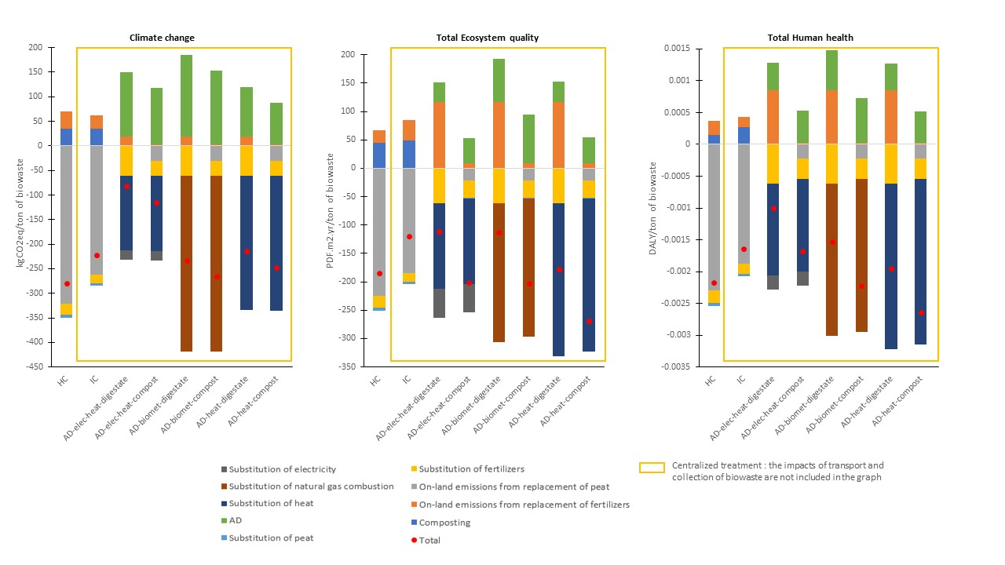
Across all impact categories, the net impacts are positive due to environmental benefits associated with the substitution of conventional products by co-products. For both home and industrial composting, the main contribution to environmental benefits comes from avoided peat use. For anaerobic digestion systems, the benefits are mainly driven by the substitution of conventional energy sources with energy produced from biogas
Regarding the two areas of protection—total ecosystem quality and total human health—the AD-heat-compost pathway performs best, with scores of −268.34 PDF·m²·yr per ton of biowaste and −2.64 × 10⁻³ DALY per ton, respectively. The AD-electricity-heat-digestate pathway shows the least favorable performance, with impacts of −111.81 PDF·m²·yr and −1.0 × 10⁻³ DALY per ton of biowaste. While both technologies derive environmental benefits from the substitution of fossil-based heat, direct biogas combustion yields greater heat production than combined heat and power. Furthermore, the land application of digestate significantly contributes to environmental burdens in the AD-electricity-heat-digestate scenario.
For climate change, home composting performs best among all technologies, mainly due to substantial benefits from avoided peat use, achieving −279.99 kg CO₂-eq per ton of biowaste. Among centralized options, AD-biomet-compost shows the best performance (−265.33 kg CO₂-eq per ton), driven by the avoided CO2-fossil of natural gas combustion. In constrast, AD-electricity-heat-digestate has the highest impacts (−82.31 kg CO₂-eq per ton of biowaste), due to the comparatively lower environmental benefits associated with CHP co-products relative to other energy recovery pathways.
It is important to remind that transport and collection impacts must also be considered to assess the total performance of centralized system options. These aspects are accounted for in the optimization modelling section, where specific-territory parameters are considered.

Results of optimization

Single objective
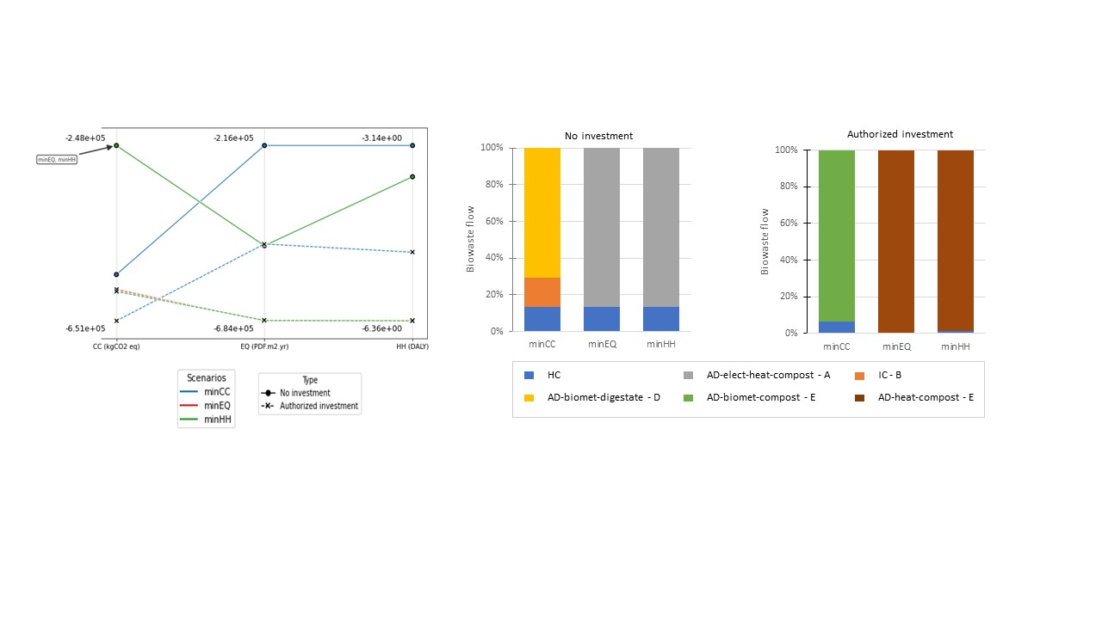

No investment scenario
Without investment, when minimizing ecosystem quality (EQ) or human health (HH), the optimization results in the same technology mix and flow distribution: 13.3% allocated to home composting (HC) and 86.73% to AD-electricity-heat-compost. From a life cycle assessment (LCA) perspective focused on human health, HC clearly performs best among the technologies available in the territory (Fig. 2). However, not all eligible waste streams—those originating from households—are directed toward this option. This is because, beyond a certain threshold, no additional benefits can be obtained from peat substitution due to the limited hobby peat market within the territory. The remaining biowaste is therefore allocated to the most efficient centralized technology available, namely AD-electricity-heat-compost. For ecosystem quality, LCA results indicate that AD-electricity-heat-compost performs better than HC. Nevertheless, not all waste is directed toward this technology. Indeed, for some municipalities, the impacts of collection and transport reduce its overall performance. As a result, the optimizer favors HC instead, until the peat substitution benefit limit is also reached.
Minimizing either HH or EQ leads to the same configuration, resulting in overall impacts of −3.72 DALY, −4.84 × 10⁵ PDF·m²·yr, and −2.48 × 10⁵ kg CO₂-eq.
When minimizing climate change (CC), a similar constraint applies: the flow allocated to HC is limited by the hobby peat market, even though LCA results identify it as the best-performing option in terms of climate change. Subsequently, 70.6% of the flow is directed to AD-biomethane-digestate (site D), while the remaining 16.11% is sent to IC (IC, site B). Although LCA results show that AD-biomethane-digestate performs better than IC, spatial factors explain this allocation. Indeed, the ARC map indicates that site B is closer to the territory than site D. Consequently, incineration is favored until the professional peat market constraint is reached. Minimizing climate change leads to overall impacts of −5.45 × 10⁵ kg CO₂-eq, −2.16 × 10⁵ PDF·m²·yr, and −3.14 DALY.

Authorized investment scenario
When investment is allowed, existing facilities are no longer utilized, and new installations are deployed depending on the optimization objective. In the case of climate change (CC) minimization, 93.5% of biowaste is directed to AD-biomethane-compost, while only 6.5% is allocated to home composting (HC). Among all available technologies, AD-biomethane-compost is the second-best performing option after HC. However, the share of biowaste sent to HC does not correspond either to the total waste generated by households or to the maximum amount that would yield environmental benefits through peat substitution. This is because the optimizer is constrained to allocate at least 93.5% of the flow to AD-biomethane-compost, which corresponds to the minimum capacity required to justify the construction of a new facility. Under this objective, the system achieves impacts of −6.51 × 10⁵ kg CO₂-eq for climate change, −4.79 × 10⁵ PDF·m²·yr for ecosystem quality, and −5.10 DALY for human health.
Regarding the scenario of total ecosystem quality minimization, all biowaste flows are directed to a single centralized technology, namely AD-heat-compost, which is also the best-performing option for this indicator among all technologies. This configuration results in impacts of −6.84 × 10⁵ PDF·m²·yr for ecosystem quality, −6.35 DALY for human health, and −5.79 × 10⁵ kg CO₂-eq for climate change.
When minimizing human health (HH) impacts, the same centralized technology is favored, receiving 98.71% of the total biowaste, as it also performs best for this indicator. The remaining 1.29% is allocated to HC and originates from a municipality with the highest collection distance among all municipalities. This optimized system yields an impact of −6.36 DALY for human health, along with −5.83 × 10⁵ kg CO₂-eq for climate change and −6.83 × 10⁵ PDF·m²·yr for ecosystem quality.

Multi-objectives
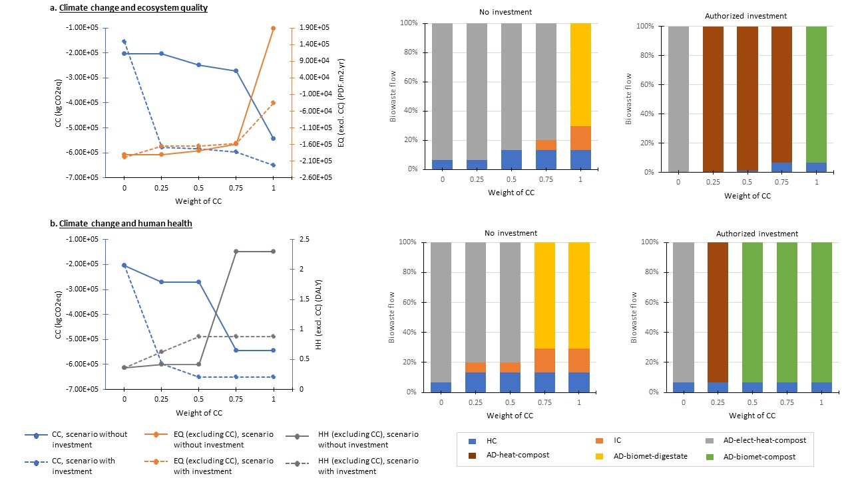

Trade-off between climate change (CC) and ecosystem quality (EQ)

No investment scenario
For CC weights ranging from 0 to 0.5, the selected technologies remain home composting (HC) and AD-electricity-heat-compost, with variations in the allocation of flows between them. When the CC weight increases to 0.75, a small fraction of biowaste (6.7%) is redirected to industrial composting (IC). Across the range from 0 to 0.75, no abrupt technological transition is observed. Over this interval, climate change impacts improve from −2.03 × 10⁵ to −2.72 × 10⁵ kg CO₂-eq, while ecosystem quality impacts excluding CC (EQ_exclCC) decrease from −1.90 × 10⁵ to −1.59 × 10⁵ PDF·m²·yr.
A major shift occurs when the CC weight reaches 1. The dominant technology switches from AD-electricity-heat-compost to AD-biomethane-digestate, accompanied by an increase in flows directed to industrial composting in order to reach the maximum peat substitution market. Between weights of 0.75 and 1, climate change performance improves substantially (from −2.72 × 10⁵ to −5.45 × 10⁵ kg CO₂-eq), while ecosystem quality deteriorates significantly (from −1.59 × 10⁵ to +1.89 × 10⁵ PDF·m²·yr).

Authorized investment scenario
When CC is not considered (weight = 0), only AD-electricity-heat-compost is selected, with 93.5% of biowaste directed to a newly installed facility and the remainder treated by existing technologies. As soon as a weight of 0.25 is assigned to CC, the system configuration changes completely, with all biowaste redirected to AD-heat-compost. This leads to a marked improvement in climate change performance (from −1.54 × 10⁵ to −5.79 × 10⁵ kg CO₂-eq), while EQ_exclCC slightly deteriorates (from −1.98 × 10⁵ to −1.65 × 10⁵ PDF·m²·yr).
Between CC weights of 0.25 and 0.75, the dominant technology remains unchanged, although the share of biowaste allocated to HC gradually increases for municipalities with higher collection distances and associated impacts. When the CC weight reaches 1, AD-biomethane-compost becomes the dominant technology. Climate change performance further improves to −6.51 × 10⁵ kg CO₂-eq, whereas EQ_exclCC benefits are substantially reduced to −3.46 × 10⁴ PDF·m²·yr.

Trade-off between climate change (CC) and human health (HH)

No investment scenario
When varying the weights of CC and HH (excluding CC), similar technologies are selected as in the CC–EQ trade-off, but system configurations stabilize earlier, i.e., at lower CC weights. From CC weights of 0 to 0.5, the dominant technology remains AD-electricity-heat-compost, with a gradual increase in the share of biowaste allocated to both home composting (HC) and industrial composting (IC). Over this range, climate change impacts improve from −2.03 × 10⁵ to −2.72 × 10⁵ kg CO₂-eq, while HH impacts excluding CC increase slightly from −0.365 to 0.415 DALY.
At CC weights of 0.75 and 1, the system configuration shifts markedly toward a combination of AD-biomethane-digestate (70.62%), industrial composting (16.11%), and HC (13.28%). As the CC weight increases from 0 to 0.75 and 1, climate change impacts improve from −2.03 × 10⁵ to −5.45 × 10⁵ kg CO₂-eq, while HH_exclCC impacts increase significantly from −0.365 to 2.3 DALY.

Authorized investment scenario
When investment is allowed and CC is not weighted (weight = 0), the existing AD-electricity-heat-compost technology is favored, receiving 93.5% of the total flow, with the remainder allocated to HC. This configuration results in impacts of −2.03 × 10⁵ kg CO₂-eq for climate change and −0.365 DALY for HH_exclCC.
At a CC weight of 0.25, AD-electricity-heat-compost is replaced by AD-heat-compost, leading to a substantial improvement in climate change performance (−5.97 × 10⁵ kg CO₂-eq), while HH_exclCC increases to 0.62 DALY. The system configuration then changes and stabilizes from a CC weight of 0.5 onward, with AD-biomethane-compost becoming the dominant technology. Under this configuration, climate change impacts reach −6.51 × 10⁵ kg CO₂-eq, while HH_exclCC rises to 0.88 DALY.

Sensitivity analysis

Sorting rate
In this sensitivity analysis, the nominal sorting rate was varied by −50% and +50% (Figure XXX).
Without investment, when the sorting rate decreases to 30%, the quantity of biowaste allocated to composting remains unchanged in order to maintain the same level of peat substitution. As a result, the reduction in sorted waste mainly affects the flows directed to anaerobic digestion. The impacts of the minimized indicators decrease by −65%, −67%, and −78% for climate change (CC), ecosystem quality (EQ), and human health (HH), respectively. When the sorting rate increases to 90%, the dominant technology (i.e., the one receiving the largest share of flows under the nominal sorting rate) receives additional inputs until reaching its maximum capacity. This corresponds to AD-biomethane-digestate in the CC minimization scenario and to AD-electricity-heat-compost in the EQ and HH scenarios. Additional technologies are then mobilized to treat the remaining waste. Under these conditions, the impacts of the minimized indicators increase by +35%, +40%, and +70% for CC, EQ, and HH, respectively.
When investment is allowed, a sorting rate of 30% does not generate sufficient waste to justify the installation of new facilities. Consequently, both the technology selection and flow distribution remain identical to the no-investment scenario at the same sorting rate. The impacts of the minimized indicators decrease further, reaching −71%, −77%, and −87% for CC, EQ, and HH, respectively.
At a sorting rate of 90%, newly installed facilities receive larger material flows. This leads to higher impacts, with the impacts of the minimized indicators increasing by +67%, +63%, and +70% for CC, EQ, and HH, respectively.
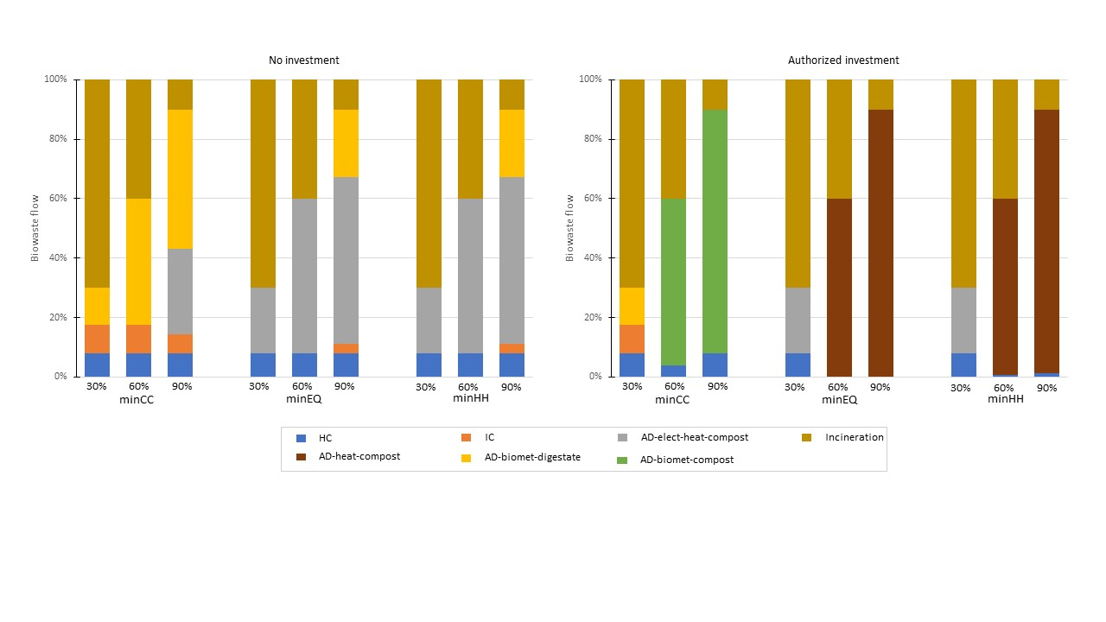

Peat market
As there is a significant uncertainty of peat market size due to lack of recent data, we varied the values used in previous optimization simulations by -80% and +80% (both for hobby market and professional market).
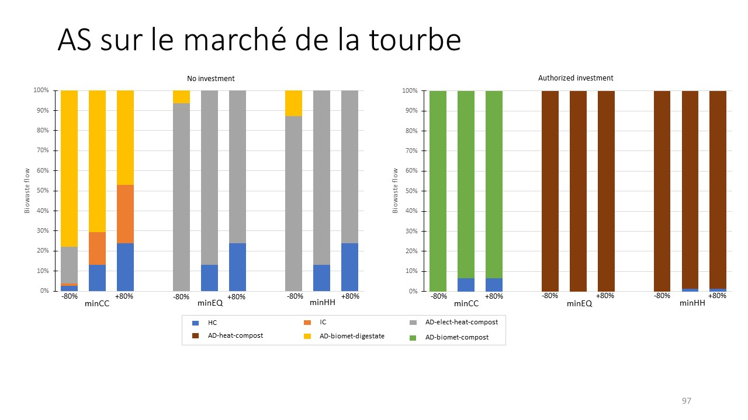

No investment scenario
In the scenario minimizing climate change (CC), when the peat market is reduced by 80%, the flow directed to AD-biomethane-digestate increases until reaching its maximum capacity, while the shares allocated to home composting (HC) and industrial composting (IC) decrease significantly. In parallel, AD-electricity-heat-compost is mobilized to ensure saturation of both hobby and professional peat markets. Conversely, when the peat market increases by 80%, flows to HC and IC rise substantially until market limits are reached. Under these conditions, the CC indicator decreases by 18% for a −80% variation in the peat market and increases by 6% for a +80% variation.
For ecosystem quality (EQ), a reduction of the peat market by 80% leads to the complete disappearance of HC. Most of the biowaste is then directed to AD-electricity-heat-compost until its capacity is reached, even if part of the compost’s agronomic value cannot be valorized due to market saturation. In contrast, increasing the peat market by 80% results in higher flows to HC, up to the maximum substitution potential of the hobby market. As a result, the EQ indicator decreases by 12% and increases by 12% for −80% and +80% market variations, respectively.
A similar trend is observed for human health (HH). At −80% of the peat market, HC is no longer selected and most flows are directed to AD-electricity-heat-compost, with part of the compost exceeding market demand and therefore not generating substitution benefits. Additionally, 12% of the flows are allocated to AD-biomethane-digestate. The HH indicator decreases by 19% for a −80% variation and increases by 8% for a +80% variation in the peat market.

Authorized investment scenario
An increase in market capacity by +80% does not lead to any change in system configurations, regardless of the minimization scenario considered.
Conversely, reducing the market by −80% results in the disappearance of the HC technology in both the climate change (CC) and human health (HH) minimization scenarios, while the configuration remains unchanged in the ecosystem quality (EQ) minimization scenario. In all cases, the amendment value of compost produced from anaerobic digestion is not fully translated into environmental benefits, as production exceeds the capacity of peat substitution markets (both professional and hobby sectors). As a result, impacts decrease by 9% for CC in the CC minimization scenario, by 5% for EQ in the EQ minimization scenario, and by 5% for HH in the HH minimization scenario.

Future electricity mix
We investigated the influence of the marginal electricity mix on the optimization results by simulating a pessimistic scenario, in which marginal electricity is fossil-based, and an optimistic scenario, in which it is entirely wind-based. In the former case, the optimization favors system configurations prioritizing AD–electricity–heat–compost pathways. In contrast, the latter scenario shows negligible deviation from the reference case, reflecting the already low-impact nature of the marginal electricity mix in France.

Discussion and limits

Discussion of results

Conventional LCA vs optimization
This study highlights that results from a conventional life cycle assessment (LCA) alone are not sufficient to determine an optimal biowaste management system at the territorial scale. When real-world constraints—such as market limitations and technological capacities—are considered, the optimal configuration often involves a combination of technologies rather than relying on the single best-performing option identified by LCA. Furthermore, the results emphasize the importance of accounting for transport and collection impacts, as these can significantly influence the degree of centralization or decentralization of the system.

Influence of the optimization objective
The choice of impact indicator strongly affects the optimized system configuration. While minimizing ecosystem quality (EQ) and human health (HH) leads to similar technological configurations, minimizing climate change (CC) results in substantially different outcomes. In particular, CC minimization prioritizes anaerobic digestion with biomethane production, whereas EQ and HH minimization favor anaerobic digestion oriented toward heat production. This difference highlights the influence of the type of substituted energy on environmental performance. In addition, multi-objective optimization—by varying the relative weight assigned to CC and damage indicators—allows the identification of compromise solutions between competing environmental objectives.

No-investment vs investment scenarios
Allowing new investments leads to a complete shift away from existing facilities, indicating that currently available technologies are not the most environmentally efficient. It also results in a more centralized system configuration. For the EQ and HH minimization scenarios, this reflects the selection of the best-performing technology. Under CC minimization, although home composting (HC) would have been more environmentally beneficial for some municipalities, these flows are instead directed to a centralized system, driven by the minimum flow required to justify the construction of a new facility

Limits
The first limitation of this study relates to the data and assumptions used, particularly in the case study. The sensitivity analysis shows that the results are strongly influenced by the size of the peat market, especially in the no-investment scenario. However, these data are derived from dated sources and are based on national-level consumption estimates. For a case study of this type, a more localized market assessment would be necessary to better reflect the specific conditions of the territory. The results are also sensitive to the biowaste sorting rate. In this study, this parameter is based on a simplifying assumption, but it could be more accurately estimated using proxies better aligned with local conditions.
More broadly, the study aims to design a future biowaste management system while assuming that current data remain valid over time. This includes, for example, the total quantity of biowaste generated, or the urbanization, which may evolve significantly in the coming years.
Finally, it should be acknowledged that the optimization framework does not cover all possible treatment options. Additional mature technologies, such as community composting, could be included. Less mature technologies should also be considered in a forward-looking perspective, such as gasification.

Conclusion
This study demonstrates the development of an optimization framework that overcomes the limitations of conventional comparative LCA by identifying the lowest-impact biowaste management pathway adapted to a given territory. As illustrated in the case study, the optimal system may involve a combination of technologies rather than a single option. The framework integrates real-world market constraints, thereby avoiding the overestimation of environmental benefits often associated with substitution. In addition, it enables a detailed spatial allocation of flows, specifying how biowaste from different municipalities is distributed across treatment technologies. Although several assumptions were required, the case study provides a first demonstration of the capabilities and relevance of the proposed approach.
These findings have important implications for stakeholders. For the LCA community, they highlight the need to refine assumptions—particularly those related to substitution effects—in order to better support decision-making at the territorial level. For local authorities, the results emphasize that the choice of optimization objective can significantly influence system configuration and may shift impacts across environmental indicators. Decision-makers should therefore consider the full value chain, including the end-use of co-products, rather than focusing solely on waste treatment processes.
Future work should focus on expanding the framework by incorporating additional treatment technologies, including both mature options such as community composting and emerging ones such as gasification. It would also be valuable to explore prospective scenarios to assess whether systems designed today remain robust under future societal and environmental changes. More broadly, this approach could be extended to support the planning of territorial bioeconomy systems beyond biowaste management.

References
Al-Rumaihi, A., McKay, G., Mackey, H.R., Al-Ansari, T., 2020. Sustainability 12, 1595.
Angelo, A.C.M., Saraiva, A.B., Clímaco, J.C.N., Infante, C.E., Valle, R., 2017. Journal of Cleaner Production 143, 744–756.
Angouria-Tsorochidou, E., Teigiserova, D.A., Thomsen, M., 2022. Resources, Conservation and Recycling 176, 105898.
Anne, T., Julia, B., Rémy, B., Sylvaine, B., Mathilde, B., Manon, V.B., Isabelle, Z., Etienne, P., 2025. Waste Biomass Valor 16, 2985–2998.
Ardolino, F., Parrillo, F., Arena, U., 2018. Journal of Cleaner Production 174, 462–476.
Ashraf, A.I., Mohareb, E., Vahdati, M., Abbas, F., 2025. Discov Sustain 6, 138.
Bahramian, M., Krah, C., Hynds, P., Priyadarshini, A., 2025. Recycling 10, 94.
Behrooznia, L., Sharifi, M., Hosseinzadeh-Bandbafha, H., 2020. Journal of Cleaner Production 268, 122217.
Favoino, E., Giavini, M., 2024. Bio-waste generation in the EU: Current capture levels and future potential.
Gentric, A., MAHE, C., BELLENOUE, K., 2022. Évaluation de la généralisation du tri à la source des biodéchets.
Gilbert, J., Siebert, S., 2022. Compost and digestate for a circular bioeconomy. Overview of Bio-Waste collection, treatmet and markets across Europe.
Kapoor, R., Ghosh, P., Tyagi, B., Vijay, V.K., Vijay, V., Thakur, I.S., Kamyab, H., Nguyen, D.D., Kumar, A., 2020. Journal of Cleaner Production 273, 123052.
Kaza, S., Yao, L.C., Bhada-Tata, P., Van Woerden, F., 2018. What a Waste 2.0: A Global Snapshot of Solid Waste Management to 2050. Washington, DC: World Bank.
Lin, Z., Ooi, J.K., Woon, K.S., 2022. Science of The Total Environment 816, 151541.
Liu, M., Ogunmoroti, A., Liu, Wei, Li, M., Bi, M., Liu, Wenqiu, Cui, Z., 2022. Science of The Total Environment 807, 150751.
Münster, M., Ravn, H., Hedegaard, K., Juul, N., Ljunggren Söderman, M., 2015. Waste Management 38, 486–495.
Oliveira, L.S.B.L., Oliveira, D.S.B.L., Bezerra, B.S., Silva Pereira, B., Battistelle, R.A.G., 2017. Journal of Cleaner Production, Sustainable Development of Energy, Water and Environmental Systems 155, 229–237.
Ravoahangy, N., Majeau-Bettez, G., Schoefs, O., 2026. Waste Management 212, 115337.
Roberts, K.P., Turner, D.A., Coello, J., Stringfellow, A.M., Bello, I.A., Powrie, W., Watson, G.V.R., 2018. Journal of Cleaner Production 196, 547–563.
Sardarmehni, M., Anchieta, P.H.C., Levis, J.W., 2022. J of Industrial Ecology 26, 748–762.
Tascione, V., Mosca, R., Raggi, A., 2016. Journal of Cleaner Production 112, 3086–3096.
UNEP (Ed.), 2024. Beyond an age of waste: turning rubbish into a resource, Global waste management outlook. UNEP, Nairobi.
Weidema, B., 2003. Market information in life cycle assessment.
Weidner, T., Graça, J., Machado, T., Yang, A., 2020. Waste Management 118, 552–562.
Zeller, V., Lavigne, C., D’Ans, P., Towa, E., Achten, W.M.J., 2020. Science of The Total Environment 745, 140690.

